How To Use

1.first login a premade guest account has been made

username: guest

password: guest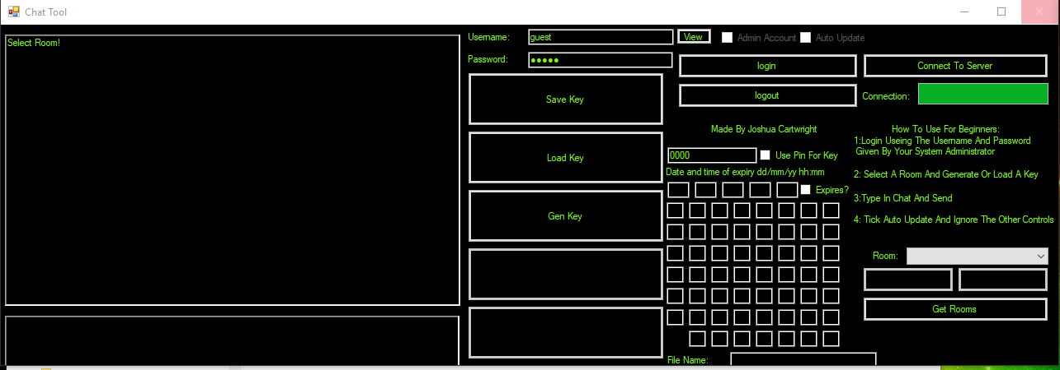

2. generate a key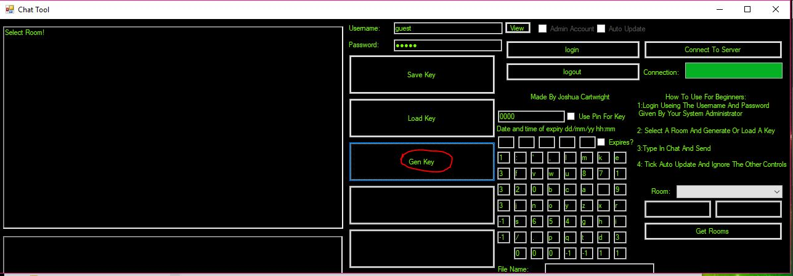

3. click get rooms

then select a room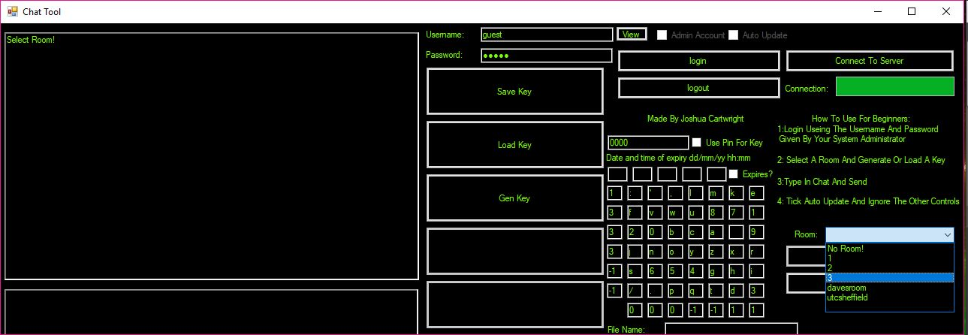

4. then I recommend pressing auto update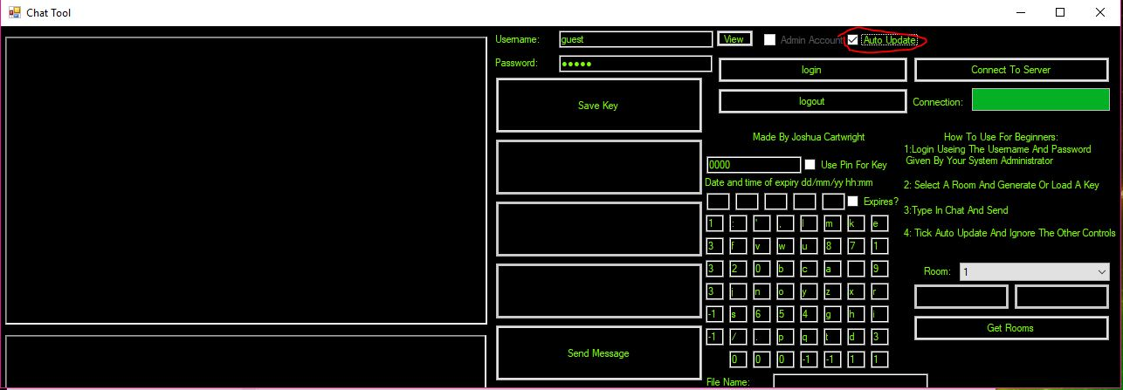

5. then type away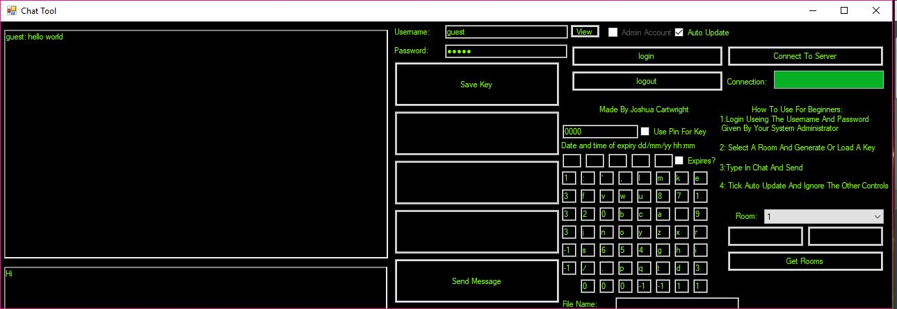

note: if the key is at any point different than the one used to create the message the text will still be encrypted. 